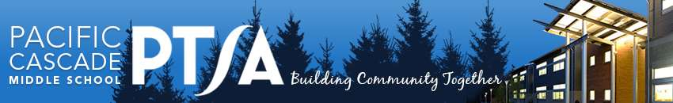
PCMS PTSA Curriculum Enrichment Grant Application
Pacific Cascade Middle School PTSA offers Curriculum Enrichment Grants to provide additional resources for PCMS staff, supporting educational enrichment and opportunities in the current academic year. Grants are evaluated on NEED, ENRICHMENT, and IMPACT. All eligible applications are reviewed by the Grants Committee who make a recommendation to the PTSA Board of Directors for a vote. Due by MONDAY, March 9, 2026
Applicant(s):

Contact E-mail:

Total Funds Requested, including taxes, shipping, and other funding sources: student or school paid portion, district funds, ISF grants, previous grants:

Specific Grant Request Description and NEED:
NOTE – online curriculum subscriptions cannot be funded.

ENRICHMENT: Describe educational qualities and merit of request?

IMPACT: How many students will be impacted by this Grant? Grade level(s)?

Additional Comments:

Complete all questions, attaching additional receipts, documentation, order details to fulfill application. Forward completed applications to the PCMS front office, attention: PTSA or via email to Marie Werbel for principal signature.
Date of Submission:
Applicant Signature:
Principal Signature:
(Attach email confirmation of grant approval request, if necessary.)

